MMF 1914H: Final Assignment

Name: Min Jae (Ian) Lee

Student Number: 996953550

**Part 2: Financial Data**

1. Please, check python file name “Min Jae (Ian) Lee MMF1914H - Part 2” for coding.

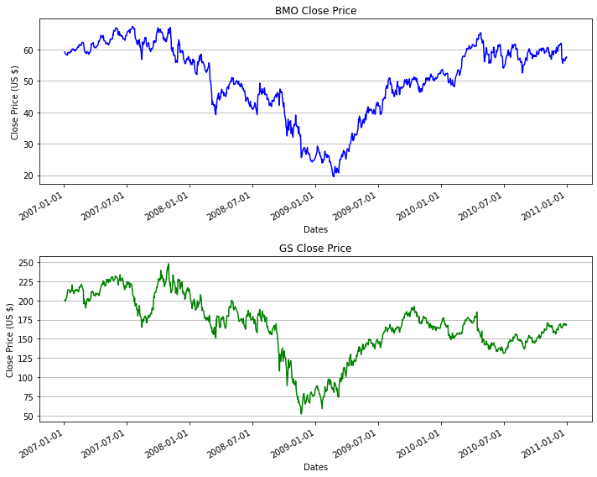

1. The daily log returns for each series are shown in python file. Please, check python file name “Min Jae (Ian) Lee MMF1914H - Part 2” for coding.

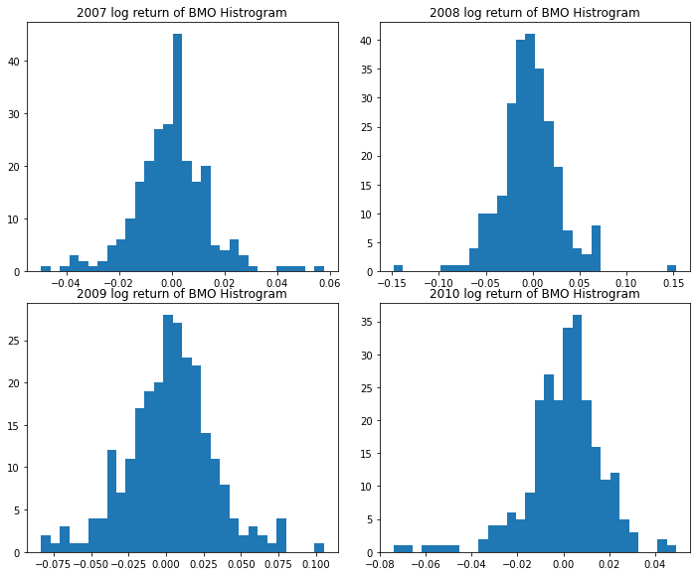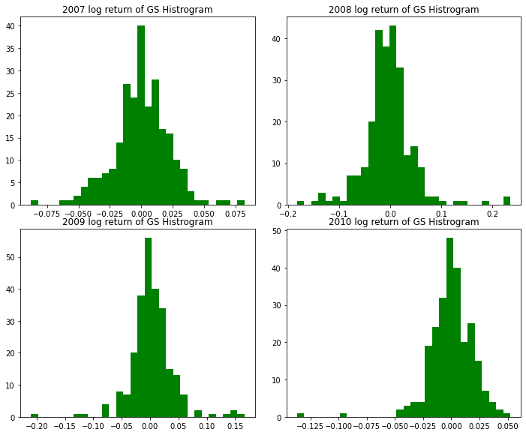

1. Answer: Standard deviations of the 2008 and 2009 data is much greater than the 2007 and 2010 data because there was the great financial crisis between 2008 and 2009. During the financial crisis, volatility in the market was very huge; therefore, the standard deviations in 2008 and 2009 was much higher than 2007 and 2010.

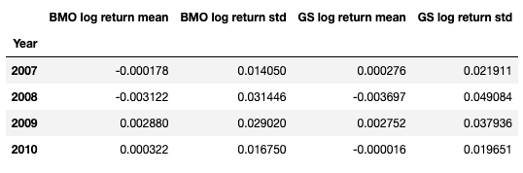

Please, check file name “Min Jae (Ian) Lee MMF1914H - Part 2” for coding.

**Part 3: Numerical Option Pricing**

$$p_{u}= \frac{e^{\left(r-q\right)∆t}-d}{u-d}$$

$$0< \frac{e^{\left(r-q\right)∆t}-d}{u-d}<1$$

$$0< e^{\left(r-q\right)∆t}-d <u-d$$

$$d< e^{\left(r-q\right)∆t}<u$$

$$We know d= e^{-σ\sqrt{∆t}} and u= e^{σ\sqrt{∆t}}$$

$$e^{-σ\sqrt{∆t}}< e^{\left(r-q\right)∆t} < e^{σ\sqrt{∆t}}$$

$$\ln{e^{-σ\sqrt{∆t}}}<\ln{e^{\left(r-q\right)∆t}}< \ln{e^{σ\sqrt{∆t}}}$$

$$-σ\sqrt{∆t} < \left(r-q\right)∆t< σ\sqrt{∆t}$$

$$\frac{-σ\sqrt{∆t}}{r-q} < ∆t < \frac{σ\sqrt{∆t}}{r-q}$$

$${\left(∆t\right)}^{2} < {\left(\frac{σ\sqrt{∆t}}{r-q}\right)}^{2}$$

$${\left(∆t\right)}^{2}< \frac{σ^{2}∆t}{{\left(r-q\right)}^{2}}$$

$$∆t< \frac{σ^{2}}{{\left(r-q\right)}^{2}}$$

$$Because ∆t< \frac{σ^{2}}{{\left(r-q\right)}^{2}} exists, 0< \frac{e^{\left(r-q\right)∆t}-d}{u-d} = p_{u} <1 satisfied.$$

$$0<p_{u}$$

$$0< \frac{e^{\left(r-q\right)∆t}-d}{u-d}$$

$${0< e}^{\left(r-q\right)∆t}-d$$

$$d< e^{\left(r-q\right)∆t}$$

$$e^{-σ\sqrt{Δt}}< e^{\left(r-q\right)∆t}$$

$$-σ\sqrt{Δt}< \left(r-q\right)∆t$$

$$The LHS will be always negative, so 0<p_{u} is satisfied.$$

$$p_{u} < 1$$

$$\frac{e^{\left(r-q\right)∆t}-d}{u-d}<1$$

$$e^{\left(r-q\right)∆t}-d<u-d$$

$$e^{\left(r-q\right)∆t}<u$$

$$e^{\left(r-q\right)∆t} < e^{σ\sqrt{Δt}}$$

$$\left(r-q\right)∆t< σ\sqrt{Δt}$$

$$∆t< \frac{σ^{2}}{{\left(r-q\right)}^{2}}$$

$$As we proved earlier, p_{u} < 1 is possible when Δt is smaller than \frac{σ^{2}}{{\left(r-q\right)}^{2}}$$

$$and since RHS is always positive and larger than Δt,$$

$$p_{u} < 1 also holds.$$

1. Please, see the python file attachment “Min Jae (Ian) Lee MMF1914H - Part 3 Q2”.
2. Monte Carlo Method is most appropriate for path-dependent options.
3. You can find the answer in the next page. In case you want to check my coding, please, see the python file attachment called “Min Jae (Ian) Lee MMF1914H - Part 3 Q4”.

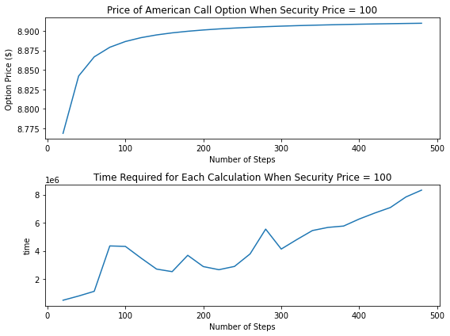

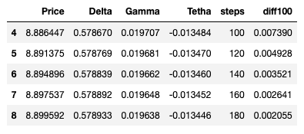

When security price is 100, it requires around 100 steps before the calculated price converges to within $0.01

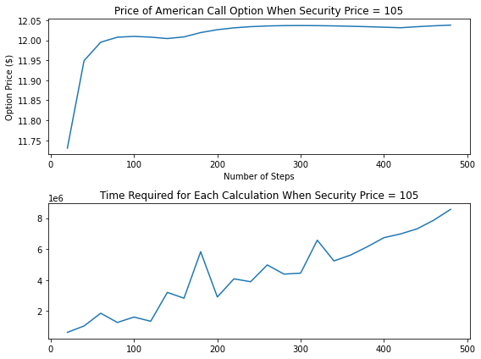

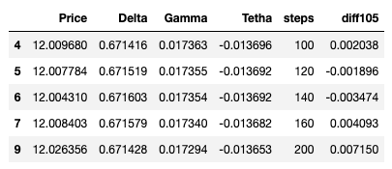

When security price is 105, it requires around 100 steps before the calculated price converges to within $ 0.01